

World of Spheri and

Cubi



*Kaloyan Dinev* ([KDDinev18@codingburgas.bg](mailto:kddinev18@codingburgas.bg)) - Team Leader + Game Developer

*Stanislav Todorov* ([SATodorov18@codingburgas.bg](mailto:SATodorov18@codingburgas.bg)) - Game Designer + Graphic Designer

*Borislav Ferdinandov* ([BFFerdinandov18@codingburgas.bg](mailto:BFFerdinandov18@codingburgas.bg)) - Documentation Writer + Voice Actor

*Rosen Papazov*([RMPapazov18@codingburgas.bg](mailto:RMPapazov18@codingburgas.bg)) - Site Developer + Presentation

*Danislav Todorov* ([DATodorov18@codingburgas.bg](mailto:DATodorov18@codingburgas.bg)) - Site Developer + Presentation

Vocational school for computer programing and innovation

Contents

History of the game 2

Elements of the game 2

Instruments for the game 2

Rules of the game 2

How to win 2

Storyline 2

Team 3

Technologies used for the creation of the project 3

Goals 3

Block diagram 4

Description of the functions and scripts used 4

## History of the game

Once upon a time there was a sphere called Spheri from The Great Land of Spheriofia. He was a good citizen, treated everyone with respect and being respected as well. But one day when the leader of Spheriofia, Ruben The Great died from unknown circumstances, The Great Tsar Johnson took his place. He was a terrible leader. Making the prices of everyday things almost impossible to afford for the medium and low class families and jailing everyone who tried to talk against him or his family. And this is when Spheri decided to take action. He wanted to take down The Great Tsar Johnson. He organized protest but he was the only one there and he was jailed. There he met Cubi which was jailed because he didn’t belong there (he was a cube and appeared in the sphere world because of a failed experiment). They became really good friends and tried to escape over 100 times when finally The Great Tsar Johnson decided to send them to a dimension where they have to complete all levels in order to acquire the special stick and escape.

## Elements of the game

Our game is skill-based platformer puzzle game. It has puzzle elements like buttons and levers, platform level elements like platforms and spikes.

## Instruments for the game

When you start the game you will spawn in something like a cage and you have to get to the finish line without dying.

## Rules of the game

1st and most important rule is to not exploit bugs! If you happen to come across one, please kindly report it to us at *example_email@\*\*\*\**

2nd is to not use cheats! This will just kill your fun.

3rd To play the game you have to move with the arrow keys and tap space two times to double jump.

4th Have fun! ☺

## How to win

In order to complete the game you have to acquire the *magical stick* which will defeat The Great Tsar Johnson thus giving you the win.

## Storyline

There is not much dialogue in the game. Only interaction (talking) that the game makes with the player is when it explains what are the controls and also when you get the *magical stick*.

## Team

*Note that here I mentioned the things that each person has most contribution for and it does not mean that they have done all of that by themselves. Each of us helped each other out in something but it was not that big thus it is not written here.

*Kaloyan Dinev* - Team Leader + Game Developer

*Stanislav Todorov* - Game Designer + Graphic Designer

*Borislav Ferdinandov* - Documentation Writer + Voice Actor

*Rosen Papazov* - Site Developer + Presentation

*Danislav Todorov* - Site Developer + Presentation

## Technologies used for the creation of the project

The game was written in C#

Development environment was Visual Studio

Cinema 4D for 3D modeling

Sony Vegas Pro 14 was used to leave only voice from the file and to render it as MP3 file

Microsoft Teams was where we communicated

The documentation was written in Microsoft Word

The presentation was made in Microsoft Power Point

## Goals

The idea behind the game came really randomly. The main goal of the game was to entertain people. I mean this is what games are made for, aren’t they? Except for the P2W ones but ours is not like this. The main problem that our game can solve is boredom. Also some of the levels are pretty hard but when the player completes them, he gets pleased with himself and he feels good which is what we want. Also that was something behind the game – to make the final levels not easy but not super hard so our players won’t rage that much ☺.

And for the future plans we would like to implement a translation button so it is accessible to more people and those who don’t speak English, more levels, boss fights and more gamemodes.

## Block diagram

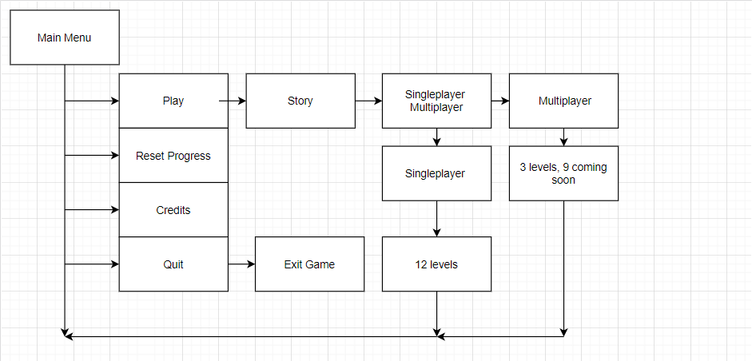

## Description of the functions and scripts used

|  |  |  |  |
| --- | --- | --- | --- |
| Name | Arguments | Purpose | Algorithm |
| AudioManager | public static AudioManager instance;    public Sound[] sounds; | Plays music and sound | Checks if a music or sound exists. If they exist gives the music pitch and volume and then plays it. |
| collusions | None | To restart the level if you hit a spike | Use OnTriggerEnter() to check if the player hits the spike. |
| FollowPlayer | public Transform target;    public float smoothSpeed = 0.125f; public Vector3 offset; | To make the camera to follow the player. | Use PixedUpdate() which is called after the Update(). To copy player’s transform with a given smooth speed. |
| gettothenextlevel | public int nextSceneLoad; | Gets to the next level. | By the function OnTriggerEnter() will check if the player is on the finish line and if it is goes to the next level. |
| LevelSelection | public Button[] lvlButtons; | To hide locked levels. | Checks which level you are and locks the next ones. |
| leverButton | public Transform plate;     public MeshRenderer blockingObject;     public BoxCollider blockingObject1; | Lever that unlocks a door when It is pressed. | By using OnTriggerEnter() we check if the player triggers the lever and if it does it removes the door. |
| MainMenu | None | Level selection | By public functions we say which button to which level leads. |
| moving | public CharacterController controller;     private Vector3 direction;     public float speed = 8;        public float jumpForce = 10;     public float gravity = -20;     public Transform groundCheck;     public LayerMask groundLayer;  public bool  ableToMakeADoubleJump = true;   public bool ableToMove = true; | Moving the player | We get the horizontal input of the player(A,D,<-,->) and the jump input(space), the direction of the character is calculated by getting the input and multiplying it with the speed. With the variable isGrounded we check if the character is on the ground and if it does he will be able to jump and when he jump he will be able to double jump and won’t be able to jump until he hits the ground again. |
| multcamerafollow | public List<Transform> players;     public Vector3 offset;     public float smoothtime = 0.55f; | Makes the camera field comfortable for the two players. | In LateUpdate() the camera field is based on the position of the two players. |
| PauseMenu | public static bool gameIsPoused = false;     public GameObject pauseMenuUI; | Pauses the game. | In Update() we check if the game is paused, if it is not we call the function Pause() which pauses the game. If the game is already paused it calls the function Resume() which resumes the game. |
| spikefollowplayer | public Transform player;     private float speed=0.05f;     public BoxCollider finish; | It makes the spikes to follow the player. | It copies the transform of the player with a little delay. |
| timingButton | public Transform button;     public MeshRenderer blockingObject;     public MeshCollider blockingObject1; | Button that unlocks a door when It is pressed for a certain amount of time. | We use OnTriggerEnter() to check if the player presses the button and if it does it removes the door. And OnTriggerExit() checks if the button is free and after certain amount of time it reveals the door. |
| voicelines | public AudioClip clip;     public float volume = 0.2f;     private bool pleyed = false;     AudioSource audio; | To play a voice line | We use OnTriggerEnter() to check if the player is in the zone where the voice line has to be played and if it does it plays the voice line and sets the variable played to true so the voice line won’t be played again. |
| subs(1-11) | public GameObject textBox;      private bool played = false; | To display subtitles. | We use OnTriggerEnter() to check if the player is in the zone where the subtitles have to be shown and if it does it displays them by the function subs() from type IEnumerator. |